Individually wrapped face visors minimising cross infection, already assembled and non-adjustable. Suitable to be stored in dry conditions. Designed to give eyes and face protection from the splashing of hazardous and infectious substances. Disposable. Can easily fit over prescription eyewear and goggles. Fits comfortably over a surgical mask.

Instructions for use:
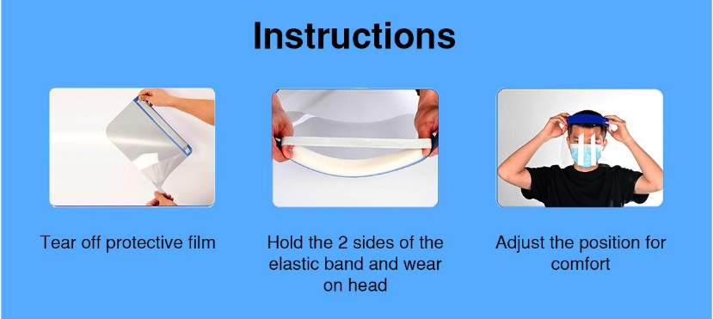
Remove outer bag and tear off plastic protective film before use.

Place the foam strip to the forehead and pull the elastic over the back of the head. Adjust until comfortable.
Headband must be positioned correctly across forehead so visor ends below the chin to give effective protection.

Steri Disposable Face Visors do not have a specific shelf life. Suitable to be transported within their individual bags and bulk packed in boxes. Branded as ‘Steri Products’ including brief description and product warnings of use. This filtering visor is manufactured for COVID-protection only and is not a PPE device for general use and shall not be used for purposes other than protection against COVID-19. The product shall not be used for more than one shift.
Supplied by Steri Products Ltd, 41 Blackwell Drive, Braintree Business Park, Braintree CM7 Manufactured by Shenzhen Yuezhi Color Printing Technology Co Ltd, North Unit, 4th Floor, Building B5, Gankang Village, Buji Street, Longgang district, Shenzhen
The Steri Disposable Face Visor comes under Category II of the PPE Regulation (EU) 2016/425 and has been tested, and has passed, CE compliance by the BSI Group The Netherlands B.V. John N Keynesplein, 1066 EP Amsterdam, The Netherlands, Company Reg 3324284, NB 2797 under BSI’s PPE for Healthcare Professionals 2020/403 – Eye protection Technical Specification. Test report 3317515 was signed off on 2/12/20 and the CE compliance certificate 738526 was issued by the BSI at the above address on 19/01/2021.

